16.43: 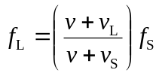
a) The direction from the listener to source is positive, so 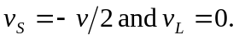
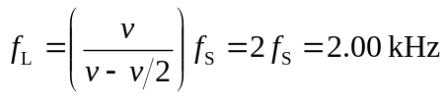
b) 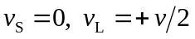
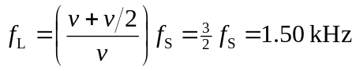
This is less than the answer in part (a).
The waves travel in air and what matters is the velocity of the listener or source relative to the air, not relative to each other.

